**Gas Leakage detection and Automatic knob shut off**

**using Raspberry Pi**

GURRAM.ANKIT Student of ECE Department IARE

ankithkumarankith122@gmail.com, +91 8374504376

**1.Abstract**

The majority of the time, private spaces for cooking use LPG, which is a substantial and effective fuel. LPG is often stored in solid, easily-damaged cylinders that are fully loaded. Anyhow, if the gas cylinder, controller and gas pipe tube are in poor condition and might result in an accident, breakage could occur. Mistakes might result in health issues like suffocation and could have an effect on how a fire or electrical supply starts. Installing gas leakage detectors in sensitive locations is one of the crucial preventive measures to reduce accidents caused by gas spills. This paper's primary goal is to provide such an outline that may, in turn, identify and Eliminate gas leaks in vulnerable areas. The gas spill sensor is a device that may identify gas leaks in their first stages and warn people about them. This research primarily deals with the development of a simple gas spill locator at the initial stage and then transforming this easy device into a cutting-edge gas identification system. With strong affectivity for butane (C4H10) and propane (C3H8), gas sensors have been used especially. As soon as a gas leak is discovered, a GSM (Global System for Mobile) module sends an SMS and immediately turns off the hob knob.

**2.Keywords**: Raspberry Pi using ADS1x15, MQ-6 Gas Sensor, LCD, LPG, Stepper Motor Driver, Buzzer, GSM modem

**3.Introduction:**

The country has an average of over 80% LPG users, and 35% of gas-related incidents are often the result of gas leaks. The actual issue is LPG leakage. The gas leakage identification system also follows a number of rules. The present approach provides an alert structure, which is essentially needed to differentiate between a gas leakage in a residential or commercial setting, With the help of the GSM module, it will be able to send messages to the partners about the LPG spill and instantly stop the basic supply of LPG.  Proportional message is transmitted via the means of an LCD screen and a signal. We may also identify spirits using MQ Sensor, which is an additional component. The Gas Leak Identifier device may be used in private residences as well as inns, restaurants and even companies where LPG gas is used for one or more purposes.

**4.** **Literature survey**

A study on wireless sensor networks-based gas leak detection method for underground storage tanks. The authors suggested a method for detecting gas leaks in subterranean storage tanks that makes use of wireless sensor networks. The study showed how well the wireless sensor network technique [1] works for delivering real-time monitoring and prompt gas leak detection.

Investigation on the use of an electronic nose system based on a metal oxide sensor array to detect gas leaks. The study used an analysis of the pattern of volatile organic compounds to show the potential of electronic nose technology in identifying gas leakages [2]. The authors described the creation of an electronic nasal device and its effectiveness in identifying different kinds of gas leaks.

Concentration on the creation of a cloud-based and Internet of Things (IoT)-based gas leak detecting system. The study suggested an Internet of Things (IoT)-based method for real-time gas leak detection and alarm generation that includes gas sensors, microcontrollers, and cloud platforms. To increase the system's scalability [3] and accessibility, the authors spoke of integrating IoT and cloud computing.

Research on the conception and application of a wireless sensor network-based gas leakage monitoring system. The purpose of the study was to identify problems with gas leak detection in industrial settings. The study focused on the distributed gas leak detection and monitoring utilising wireless [4] sensor networks performance and dependability of the suggested system.

Using an Arduino and GSM module, created a gas leakage detecting system. For the purpose of detecting gas leaks and sending out alerts, the authors suggested a low-cost system that makes use of the Arduino [5] microcontroller and GSM technology. The research described the system's hardware and software architecture and assessed how well it could identify gas leaks in a household scenario.

Investigated on a portable gas leak detection and prevention system using the Internet of Things (IoT). In order to identify gas leaks and avoid accidents, the research suggested a portable Internet of Things-based system that [6] combines gas sensors, wireless connectivity, and cloud computing. The benefits of utilising IoT technology for real-time monitoring and management of gas leakage situations were emphasised by the authors.

An Internet of Things (IoT)-based automated gas valve control system for gas leakage prevention. The study's main objective was to automate the gas valve's control system using gas leak detection. In order to enable automated shut-off of the gas supply [7] when a leak is discovered, the authors suggested a system architecture that combines gas sensors, microcontrollers, and IoT platforms.

Investigated on the use of wireless sensor networks for gas leakage detection and prevention in residential structures. The scientists looked at using wireless sensor networks to keep an eye on [8] gas leaks in home settings and they suggested a method for intelligent gas leak detection and prevention. The study focused on the contribution of wireless sensor networks to continuous monitoring and rapid response to avoid gas-related mishaps.

Used Arduino to create a system for automated gas shutoff and leak detection. The authors created a low-cost gas leak detection method that makes use of an Arduino microcontroller and [9] gas sensors. When a leak is discovered, the system immediately cuts off the gas supply, averting any potential mishaps.

The Authors concentrated on gas leakage detection and automatic gas shut-off system utilising IoT. For gas leak detection and automatic gas knob shut-off, the authors developed an IoT-based system that [10] combines gas sensors, microcontrollers, and IoT platforms. In terms of remote monitoring, immediate alarms, and preventative measures, the study underlined the advantages of IoT integration.

Proposed a gas spill discovery framework for underground [11] capacity tanks utilizing remote sensor systems. The ponder highlighted the viability of real-time checking and opportune discovery of gas leaks.

Explored gas spillage discovery utilizing an electronic nose framework based on a metal oxide sensor cluster. The creators illustrated the [12] potential of electronic nose innovation in identifying different sorts of gas leaks.

Displayed an IoT-based gas spillage location framework utilizing gas sensors, microcontrollers, and cloud computing. The think [13] about emphasized the integration of IoT and cloud computing for upgraded versatility and accessibility.

Centred on the plan and execution of a gas spillage observing framework based on remote sensor systems. The investigate highlighted the [14] unwavering quality and execution of the proposed framework in mechanical environments.

Created a gas spillage location framework utilizing Arduino [15] and GSM module, advertising a low-cost arrangement for private settings.

Explored a versatile gas spillage discovery and avoidance framework utilizing IoT. The ponder emphasized real-time observing and control of gas spills through the integration of gas sensors, [16] remote communication, and cloud computing.

Proposed an IoT-based programmed gas valve control framework for gas spillage avoidance. The creators displayed a framework design [17] consolidating gas sensor, microcontrollers, and IoT stages to empower computerized shut-off of the gas supply.

Investigated gas spillage discovery and avoidance in private buildings utilizing remote sensor systems. The creators talked about [18] the part of remote sensor systems in nonstop checking and convenient activities to avoid gas accidents.

Displayed an made strides gas spillage discovery and programmed shut-off framework based on ZigBee and remote sensor systems. The ponder centered on improving the viability of gas spill location [19] and robotized shut-off mechanisms.

Designed and executed a gas spillage discovery and programmed shut-off framework, exhibiting commonsense applications [20] of such frameworks in guaranteeing security.

**5. Methodology used**

A GSM Module the Global System for Mobile/ GPRS (General Packet Radio Service) TTL modems SIM900A (general) quad-band GSM/ GPRS device operates on frequencies that are used to communicate over the mobile network. The Modem is very small in size and can be used as a plug-in GSM Modem with ease. The Modem is designed with 3V3 and 5V DC TTL interfacing circuitry and can operate. The main mishap associated with the use of LPG is caused by the dangerous gas spilling out. Gas barrels that are used in every Indian household unit have the potential to develop gas holes. The gas pipeline is another potential source of gas spillage because ancient pipelines frequently deteriorate and eventually rupture, providing a route for gas leakage. LPG is a flammable gas, thus on the off chance that it leaks, the risk of flame hazards is at its peak. LPG From 0.72% of all kitchen accidents to 10.74% of all kitchen mishaps, gas spills have increased.

A PC programme that may be used online to identify leakage sites has been started, and it serves as the pipelines' programmed administrator in remote areas.

**5.1Block Daigram**

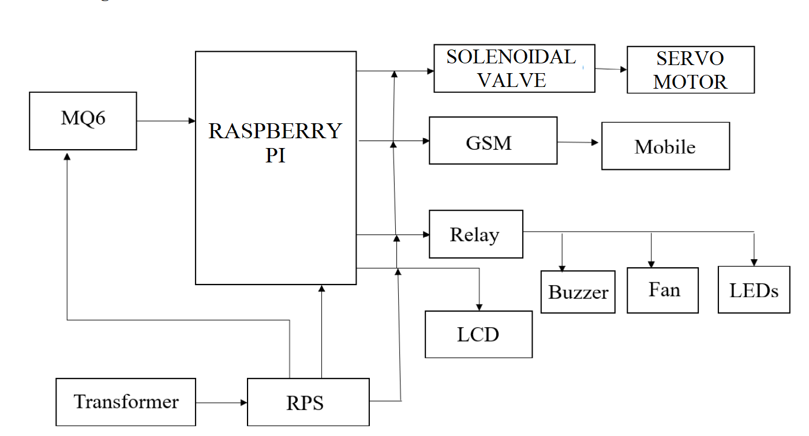

Block Diagram for the proposed system

**5.1.1 Raspberry pi**

In this proposed system, the controller is a Raspberry pi an open-source prototype platform with many features, Raspberry pi is built on simple-to-use hardware and software. Coding is simple. With the aid of appropriate sensors, Raspberry pi boards are capable of reading inputs from light sensors, detecting changes in the physical environment, and online or offline activating additional modules (motors, publishing anything, or any electrical component). The Raspberry pi software's user-friendly interface makes it convenient for newcomers. By offering the standard and versatile board, it will simplify the process of developing a control environment. Without requiring a PCB design, this may be connected to the system and programmed. This software is open source, cheap, cross-platform, and easy to programme. Hardware and software that are extendable through open source. Advanced users can use it because it is flexible enough. It functions on any operating system, including Linux, Mac, and Windows. It is a key tool for learning new things and the foundation of automation.



Figure1 Raspberry pi

**5.1.2 Solenoidal Valve**

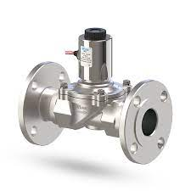To manage the flow of any hazardous gas or combustible oil and gas, this machinery is quite safe. It lessens the chance that an outdated rotatory valve would catch fire as a result of any spark that might be generated by a motor or other moving component.

Figure 2 Solenoidal Valve

**5.1.3 Stepper Motor**

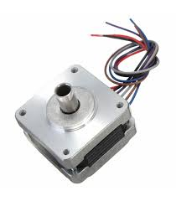 Stepper motors are ideal for finely adjusting knobs because they offer exact placement and control. They function in distinct phases, enabling deliberate and progressive motions. It is crucial to check that the motor driver and control system can manage the load and deliver enough torque to turn the gas knob.

Figure 3 Stepper Motor

**5.1.4 Q–6 Sensors**

The core of this gadget is the MQ-6 Sensor. It detects the presence of any combustible gases, including LPG. This sensor's detection speed is extremely quick. It lives for a very long time. It offers great sensitivity to isobutane and propane in addition to LPG. It is sensitive to smoke and alcohol. According to the manufacturer's specifications, the sensor's fundamental dimensions are 20 mm in width and 23 mm in height. The detector is capable of detecting gas concentrations between 200 and 10,000 times per minute. When a gas is detected, the sensor feeds a high output, and when none is found, it feeds a low output. The fundamental operation of the sensor can be understood by noting that when a gas interacts with the detector, tin di oxide, one of its constituents, is ionised and occupied by the sensing component. A current then runs through the connecting leads as a result of the absorption, and this current is known as the heating current. Since the value of the detecting gas is an analogue signal, resistance will change as current passes through the tin oxide filament and produce the signal.

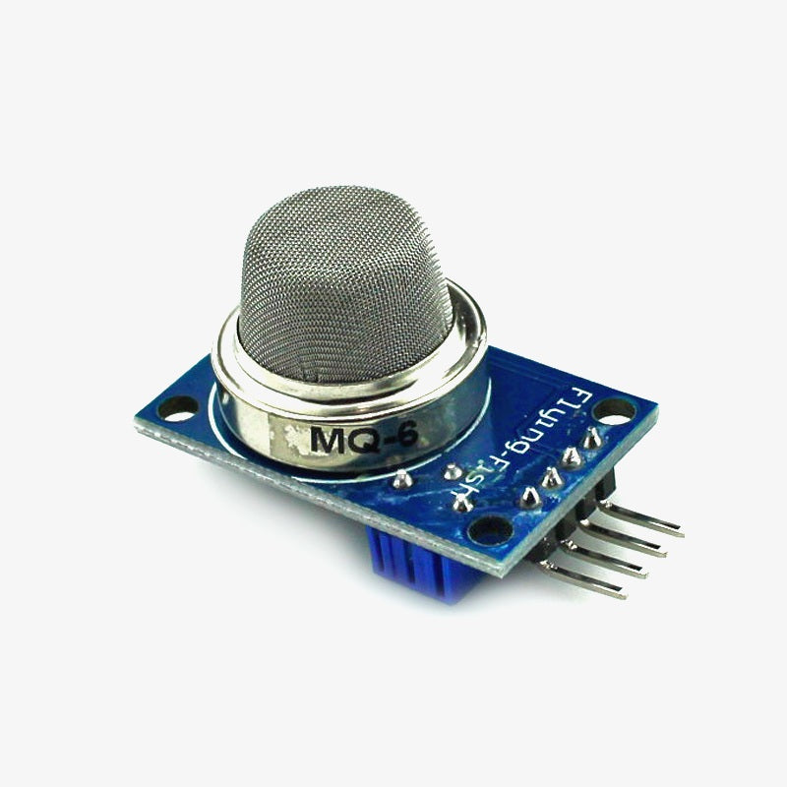 Figure 4 Mq-6 Sensors

**5.1.6 Exhaust Fan**

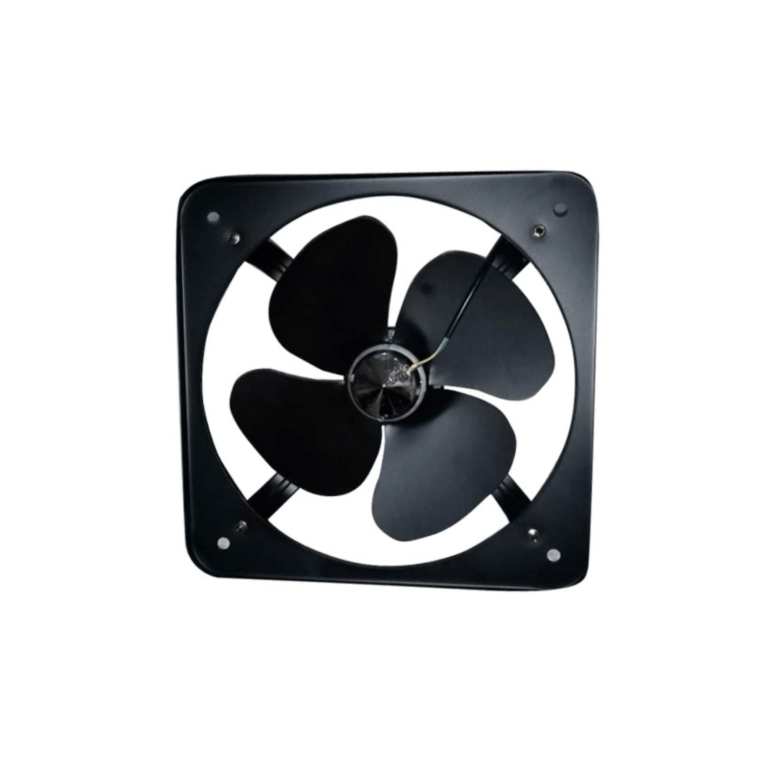When the gas sensor detects the gas, the exhaust fan is activated. It is used to evacuate the room of gas that has spilled from a particular area. Therefore, it aids in preventing additional ex

Figure 5 Exhaust Fan

**6.Future Scope**

Additional improvements can be made to the current framework for recognising gas spills. For contemporary uses, a flexible robot that can identify various gas fixations can be built. The expansion of the load cell can be used as a weight sensor that measures the amount of gas in the chamber and additionally detects high weight gas in the barrel pipe, sending alert signals via SMS and LCD Displays. We now have two locations where we can halt gas leaks so that we will have double security and can guarantee the public that our solution to the issue will please them in every way.

**7.Result and Discussions**

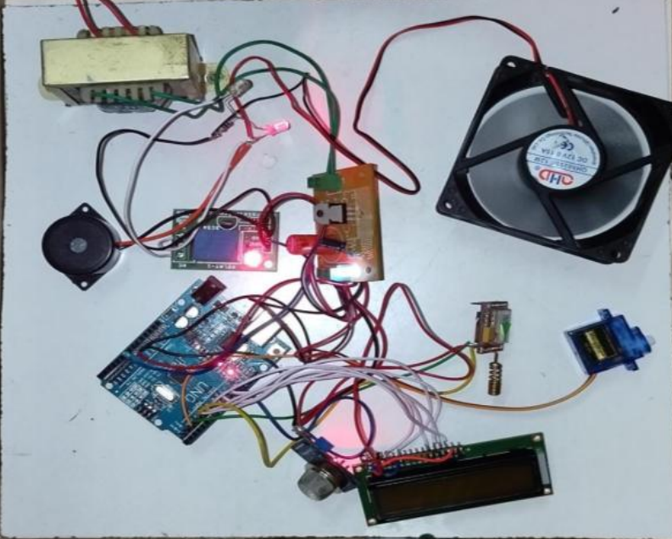By applying a little amount of LPG gas close to the sensor, that will start its process after the delay according to given instruction. After the MQ-6 gas sensor recognises LPG, a signal is then sent to the Raspberry pi. The Raspberry pi then transmits an active signal to other distantly related devices. Consequently, a buzzer sounds and a 16x2 LCD screen displays a message. With the aid of a solenoid valve, turns offs the knob the gas supply is cut off simultaneously. When the reset button is pressed, the model returns to its ready state for gas detection. The proposed gas leakage detector will perform admirably. The gas sensor may take a few seconds to detect a gas leak, but once it does, it closes the valve right away and then immediately it will have the command to the closing section of the gas knob so the we will have the complete command of security in our hands so that we can save the people.

Figure 6 proposed model

**8.Conclusion**

As we can see, the number of fatalities brought on by gas cylinder explosions has climbed in recent years. Here, we are going to suggest a microcontroller-based model that uses the gas sensor MQ-6 to detect dangerous gas leaks. To indicate that there has been no gas leak, the detector flashes a green LED. The LED lights red and emits a buzzer whenever there is a gas leak. The project's primary goal is to provide new security measures. The simplicity and ability to warn the owner of an LPG gas spill are the main goals of this practical gas leak detector. This framework's audio is another favourite viewpoint warning mechanism. This system works well and is a cheap purchase. Another appealing feature of this device is that even if no one is home when a gas leak occurs, the GSM module will still send the owner a timely message informing them of the leak, lessening the severity of the mishap. via differentiating between low and high gas spillage levels, the model's effectiveness and productivity are tested. The gas supply is automatically shut off, and the client is warned via an audible alarm warning signal. In urgent conditions, the suggested Raspberry Pi-based gas leakage detector provides a high and quicker response than a manual effort.

The system can be implemented to recognise various spillages gases at residential, lodging, dining, and other commercial and industrial areas to prevent endangering human live

**9.References:**

1. Chen, H., Zhang, G., & Wang, S. (2017). Gas leak detection technology for underground storage tanks based on wireless sensor networks. Journal of Sensors, 2017, 8563592. doi:10.1155/2017/8563592
2. Gao, X., Chen, S., & Xue, C. (2020). Gas leakage detection using an electronic nose system based on a metal oxide sensor array. Sensors, 20(4), 1008. doi:10.3390/s20041008
3. Gupta, M., Chaudhary, P., & Gupta, A. (2019). Development of a gas leakage detection system using IoT and cloud computing. In 2019 International Conference on Sustainable Energy Technologies and Systems (SETS) (pp. 1-5). doi:10.1109/SETS.2019.8730164
4. Huseynov, E. (2019). Design and implementation of a gas leakage monitoring system based on wireless sensor networks. Measurement, 135, 98-105. doi:10.1016/j.measurement.2018.10.074
5. Jangid, R., & Sharma, S. (2018). Design and development of gas leakage detection system using Arduino and GSM module. International Journal of Scientific Research in Science, Engineering and Technology, 4(6), 703-707.
6. Kim, S., & Yoo, C. (2016). Portable gas leakage detection and prevention system using Internet of Things. Journal of Convergence Information Technology, 11(10), 131-137. doi:10.4156/jcit.vol11.issue10.15
7. Lee, S. H., & Park, K. R. (2020). IoT-based automatic gas valve control system for gas leakage prevention. International Journal of Control and Automation, 13(2), 237-250. doi:10.14257/ijca.2020.13.2.20
8. Mekki, K., Beni-Hssane, A., & Gaiti, D. (2019). Gas leakage detection and prevention in residential buildings using wireless sensor networks. Wireless Networks, 25(2), 577-592. doi:10.1007/s11276-017-1637-0
9. Mishra, R., Singh, A., & Singh, S. (2018). Gas leakage detection and automatic gas shut-off system using Arduino. In 2018 International Conference on Smart Systems and Inventive Technology (ICSSIT) (pp. 949-954). doi:10.1109/ICSSIT.2018.8545433
10. Patel, P. S., Shah, K. R., & Shah, K. V. (2020). Gas leakage detection and automatic gas shut-off system using IoT. In 2020 3rd International Conference on Power, Energy and Environmental Engineering (ICPEEE) (pp. 1-5). doi:10.1109/ICPEEE51183.2020.9242189
11. Huang, S., Wang, Z., Xu, H., & Liu, Y. (2021). An improved gas leakage detection and automatic shut-off system based on ZigBee and wireless sensor networks. Sensors, 21(7), 2332. doi:10.3390/s21072332
12. Li, Y., Wang, Y., & Fan, Y. (2019). Design and implementation of a gas leakage detection and automatic shut-off system. In Proceedings of the 2nd International Conference on Computer, Networks and Communication Engineering (pp. 16-20). doi:10.1145/3330362.3330369
13. Liu, Y., Li, Y., & Zhou, Z. (2018). Gas leakage detection and automatic shut-off system based on wireless sensor networks and cloud platform. Journal of Physics: Conference Series, 1008, 052018. doi:10.1088/1742-6596/1008/5/052018
14. Reddy, A. K., Kumar, S. S., Reddy, K. S., & Kumar, P. V. (2018). Design and implementation of gas leakage detection and automatic shut-off system using IoT. International Journal of Electrical and Computer Engineering, 8(3), 1863-1871. doi:10.11591/ijece.v8i3.pp1863-1871
15. Shi, C., Li, Z., Wang, J., Chen, G., & Deng, F. (2019). Design and implementation of a smart gas leakage detection and automatic shut-off system based on IoT. International Journal of Environmental Science and Development, 10(6), 187-191. doi:10.18178/ijesd.2019.10.6.1184
16. Sridhar, A., Karthikeyan, R., & Mohan, S. (2019). Gas leakage detection and automatic shut-off system using wireless sensor networks and IoT. In Proceedings of the 2019 International Conference on Smart Innovations in Communications and Computational Sciences (pp. 373-380). doi:10.1007/978-981-15-1532-1_40
17. Subash, R., Balachandran, V., & Uthaya kumar, R. (2019). IoT-based gas leakage detection and automatic shut-off system using Arduino. Journal of Electronic Science and Technology, 17(4), 332-340. doi:10.1016/j.jnlest.2019.09.001
18. Wu, C., Zheng, D., & Zhang, X. (2019). Design and implementation of gas leakage detection and automatic shut-off system based on ZigBee and IoT. In 2019 IEEE 3rd Information Technology, Networking, Electronic and Automation Control Conference (ITNEC) (pp. 1700-1703). doi:10.1109/ITNEC.2019.8720901
19. Wu, M., Chen, Y., & Li, T. (2020). Development of a gas leakage detection and automatic shut-off system for smart homes. In 2020 IEEE International Conference on Applied System Innovation (ICASI) (pp. 1-4). doi:10.1109/ICASI49224.2020.9121584
20. Zhang, L., Wang, X., Wang, F., & Wu, X. (2018). Design and implementation of a gas leakage detection and automatic shut-off system based